Module 5.1: Java Generics

Contents
- Java Generics 1
- Advantages of Generics 2
- Disadvantages of Generics 2
- Applications of Generics 4
- Type Erasure 4
- Java's Collections Framework 5
- ArrayList 6
- When to Use ArrayList 6

Java Generics
Java Generics allow you to create classes, interfaces, and methods that can operate on any specified type without needing to define them for each object type. Generics help achieve type safety and reduce redundancy, making the code more reusable and flexible.
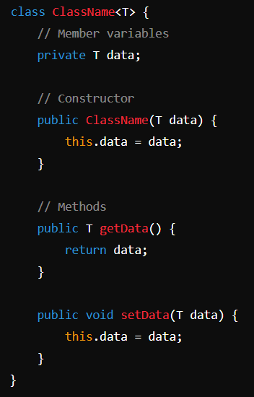
Generic Classes: A generic class is a class that can operate on objects of various types while providing compile-time type safety. It allows you to define a class with a type parameter that can be specified when creating an instance of the class.
Generic Method: are methods that introduce their own type parameters. This allows you to create methods that can operate on different types of data.
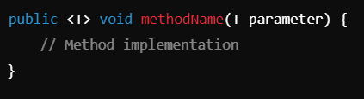
Key Points in Generic Class and Methods
- Type Parameters: In both generic classes and methods, type parameters (e.g., T, E) can be any identifier, and you can use multiple type parameters (e.g., <T, U>).
- Instantiation: You can create instances of generic classes with specific types (e.g., Box<Integer>), ensuring type safety.
- Type Inference: Java can often infer the type parameters when you instantiate a generic class or call a generic method.
- Bounded Type Parameters: You can restrict the types that can be passed to generic classes or methods using bounds (e.g., class Box<T extends Number>).
- Static Members: Static members of a generic class cannot use the type parameters, but they can use a specific type.

Advantages of Generics
- Type Safety: Ensures that only the specified data type is used, reducing runtime errors.
- Code Reusability: Allows developers to create reusable code components that work with any object type.
- Elimination of Casting: Reduces the need for explicit type casting, simplifying code and improving readability.
- Stronger Type Checks: Provides compile-time checks, catching type-related errors earlier in the development process.
- Generic Algorithms: Facilitates the development of algorithms that can operate on various data types without code duplication.
- Improved Performance: Reduces the overhead of type casting, leading to better performance.
- Easier Maintenance: Code is cleaner and easier to maintain due to less boilerplate code.
- Support for Collections: Enhances the Java Collections Framework, allowing for type-safe collections.
- Flexibility: Enables the creation of data structures that can store any object type.
- Interoperability: Allows for more seamless integration with existing Java APIs and libraries.

Disadvantages of Generics
- Complexity: Can add complexity to code, making it harder for beginners to understand.
- Limited Support for Primitive Types: Only reference types can be used; primitives must be wrapped in their corresponding wrapper classes.
- Type Erasure: At runtime, generic type information is erased, which can limit some functionality.
- Cannot Create Generic Arrays: Creating arrays of generic types is not allowed, leading to workarounds.
- Incompatibility with Older Code: May complicate interactions with legacy code that doesn't use generics.
- No Primitive Types: Generics do not support primitive types (e.g., int, char). Instead, you must use their wrapper classes (e.g., Integer, Character).
- Raw Types: Using raw types (unparameterized generics) is allowed but discouraged, as it bypasses type safety and can lead to runtime errors.
- Wildcards Confusion: Use of wildcards can be confusing and lead to complex code structures.
- Compile-Time Restrictions: Some type restrictions may hinder flexibility in certain scenarios.
- Requires Careful Design: Generics must be designed thoughtfully to avoid misuse and maintain readability.
- Limited Type Information: Lack of runtime type information can lead to issues with reflection.
- Overhead for Some Scenarios: In certain cases, using generics may introduce overhead that affects performance.
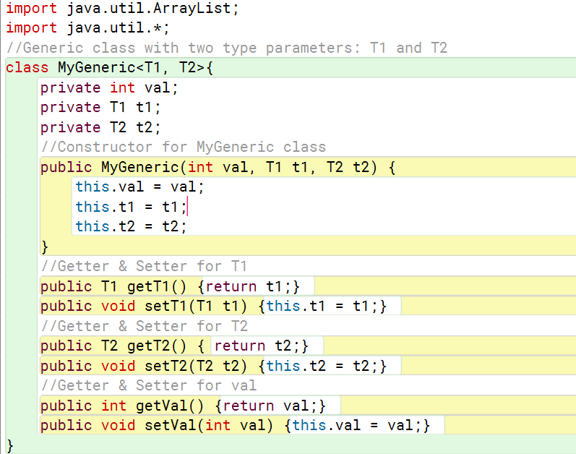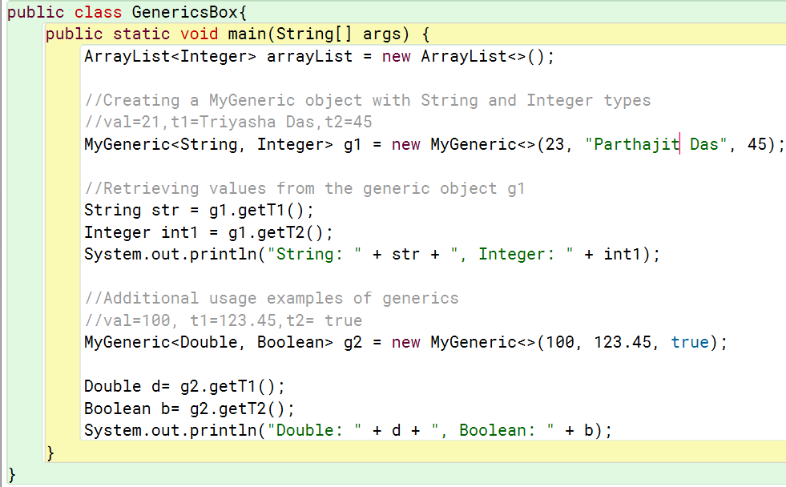
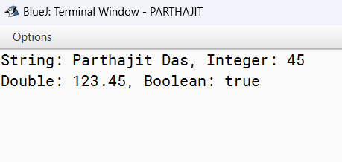

Applications of Generics
- Collections Framework: Used extensively in Java's Collection classes (e.g., List, Set, Map).
- Custom Data Structures: Enables the creation of type-safe custom data structures like stacks, queues, and trees.
- Generic Algorithms: Facilitates the development of algorithms that can work with different data types.
- Type-safe APIs: Helps create APIs that ensure type safety, reducing errors in client code.
- Sorting and Searching: Enables generic methods for sorting and searching that work with various data types.
- Functional Interfaces: Commonly used in functional interfaces for lambda expressions and streams.
- Service-Oriented Architecture: Supports the development of generic services that can handle different data types.
- Framework Development: Used in building frameworks that require flexibility with data types, like Spring.
- Database Operations: Helps in creating generic data access objects (DAOs) that work with different entities.
- Testing: Facilitates the creation of generic test cases that can be reused across different data types in unit testing.

Type Erasure
Type Erasure is a fundamental concept in Java generics that occurs at runtime. It refers to the process by which the Java compiler removes all information about generic types after type checking is complete. This allows for backward compatibility with legacy code that does not use generics.
- Removal of Type Parameters: Generic type parameters are replaced with their bounds or Object after compilation.
- Loss of Generic Type Information: Type information is not available at runtime, limiting certain type-related operations.
- Automatic Casting: The compiler adds necessary casts to convert Object back to the specific type when retrieving items.
- Bounded Types: Bounds are replaced with the first bound type; additional bounds are ignored.
- Static Members: Static members cannot use type parameters directly.
- Raw Types: Raw types (unparameterized generic types) are allowed but bypass type safety.
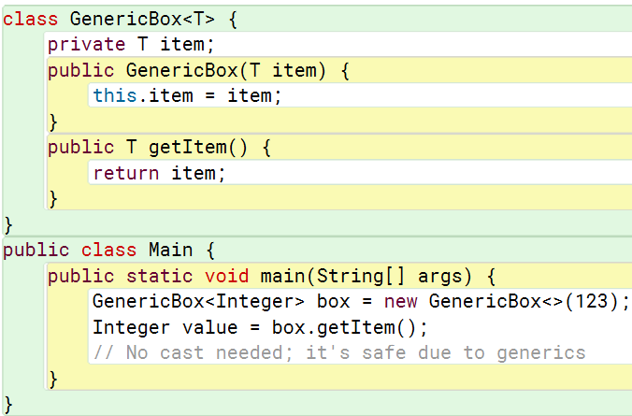
After Type Erasure, the GenericBox class would look like this:
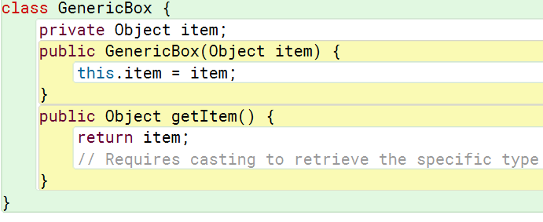
Implications of Type Erasure
- Runtime Type Information Loss: No access to generic type information at runtime, limiting reflection capabilities.
- Backward Compatibility: Ensures generics work with legacy code that predates their introduction.
- Type Safety Limitations: Potential for runtime exceptions due to type casting.
- No Performance Overhead: Since type information is erased, there’s no runtime performance cost associated with generics.
- Limited Operations: Certain operations, like instanceof, cannot be performed on generic types at runtime.

Java's Collections Framework
Java's Collections Framework is a unified architecture that provides data structures and algorithms for storing and manipulating groups of objects. It offers various interfaces, implementations, and algorithms to handle collections of data efficiently.
- Generics: Collections are strongly typed using generics, ensuring type safety and reducing runtime errors.
- Iterators: The Iterator interface provides a way to traverse collections without exposing their underlying structure.
- Concurrent Collections: Java provides thread-safe collection implementations (e.g., ConcurrentHashMap, CopyOnWriteArrayList) for concurrent programming.
- Utility Methods: The Collections class provides static methods for operations such as sorting, searching, and synchronizing collections.
- Stream API: The Collections Framework is integrated with the Stream API, allowing for functional-style operations on collections.
Key Interfaces
- Collection: The root interface for the collection hierarchy. It defines basic methods for handling groups of objects.
- List: An ordered collection (also known as a sequence) that allows duplicate elements. Key implementations include:
  - ArrayList: A resizable array implementation, offering fast random access.
  - LinkedList: A doubly linked list implementation, suitable for frequent insertions and deletions.
- Set: A collection that does not allow duplicate elements. Key implementations include:
  - HashSet: Uses a hash table for storage; offers constant-time performance for basic operations.
  - LinkedHashSet: Maintains insertion order while using a hash table.
  - TreeSet: Implements a sorted set, storing elements in natural order or by a specified comparator.
- Map: An object that maps keys to values, with no duplicate keys allowed. Key implementations include:
  - HashMap: Uses a hash table; provides constant-time performance for basic operations.
  - LinkedHashMap: Maintains insertion order while using a hash table.
  - TreeMap: Implements a sorted map, storing key-value pairs in natural order or by a specified comparator.
- Queue: A collection used to hold elements prior to processing. Key implementations include:
  - PriorityQueue: Orders elements based on their natural ordering or a provided comparator.
  - ArrayDeque: A resizable array implementation of the deque interface.
Advantages
- Ease of Use: Provides ready-to-use data structures and algorithms.
- Performance: Optimized implementations for different use cases.
- Flexibility: Supports various data structures, allowing developers to choose the best one for their needs.
- Interoperability: Works seamlessly with Java's other core libraries and features.

ArrayList
ArrayList is a part of Java's Collections Framework and provides a resizable array implementation of the List interface. It allows for dynamic resizing, meaning the size of the ArrayList can grow or shrink as needed when elements are added or removed.Key Features of ArrayList
- Dynamic Size: Unlike arrays, which have a fixed size, ArrayList can grow as elements are added, allowing for flexible data storage.
- Ordered Collection: Elements in an ArrayList maintain the order of insertion, and you can access them using their index.
- Allows Duplicates: ArrayList can store duplicate elements, meaning you can add the same value multiple times.
- Fast Random Access: Provides O(1) time complexity for accessing elements using an index due to its underlying array structure.
- Performance: While adding elements at the end of the list is generally O(1), adding elements in the middle or beginning can be O(n) due to shifting.

When to Use ArrayList
  - Dynamic Sizing: You need a resizable array that can grow or shrink as elements are added or removed.
  - Fast Random Access: You require fast access to elements by index (O(1) time complexity).
  - Ordered Collection: You need to maintain the insertion order of elements.
  - Duplicates Allowed: You want to store duplicate elements.
  - Frequent Reads: Your use case involves frequent retrievals (get()) and relatively fewer insertions or deletions.
  - Sequential Inserts at the End: You primarily insert elements at the end of the list, which is efficient.
  - When Thread Safety is Not Required: You don't need a thread-safe collection.
  - Low-Memory Footprint: You want a relatively compact data structure for storing elements.
  - When the Number of Insertions/Deletions is Minimal: You don't need frequent modifications (additions/removals) in the middle of the list.
  - Need for a General-Purpose List: You need a flexible and widely used list implementation for general purposes.
